Web Design Final Exam
You have been assigned to create the beginnings of a web site for a vacation spot in Hawaii. All of the pieces you need are provided in this document, all you need to do is apply the appropriate HTML coding.

Create a folder and name it Final_Exam_your last name. All files created are to be saved in this folder and this folder is to be saved in My Documents. Create an index page that contains the following information and layout. All graphics are provided on the images page and need to be saved to your folder. You may use either tables or frames (or both) for the index page.

Index Page Instructions
_____Save the page as index in the final exam folder with your name
_____All three graphics are located on the images page and should be placed where the text for each graphic is located.
_____All graphics must have alt text describing them.
_____No lines should appear in the final page. All text is dark blue in color and the background is a light aqua blue (the colors do not have to match, simply make them similar in design to what you see here).
_____ Make the www.eht.com hyperlink link to www.tombarefoot.com
Welcome to Extreme Hawaiian Tours
Graphic_1  About EHT  One Day Tours  The Ultimate Package  Extreme Hawaiian Tours  436 Sunset Lane  Maui, HA  1-800-786-9000  www.eht.com  Graphic_2 | Graphic_3

About Extreme Hawaiian Tours Page
_____Save the page as aeht in the pages folder (you will have to create this folder).

Here is the content and layout for this page.

About Extreme Hawaiian Tours

Extreme Hawaiian tours was started in 1995 by Sandy Rouch and Wendy Camp after they found a vacancy in the area of tours catering to those seeking thrills and excitement. Sandy is an avid hang glider and paraglider while Wendy is a mountain climber, biker and surfer. The two joined forces to provide vacations that appeal to the thrill seeker in all of us. Here are some quotes from satisfied customers:

Our two day mountain bike tour was the best Hawaiian experience
we have ever had. The tour was well planned, the accommodations
were wonderful and the food was great. We would recommend EHT
to everyone.
Michelle and Randy Radcliff

The Seven Pools rafting and gliding tour was the best, full of
non-stop excitement and thrills. Although the tour was full of
action and adventure safety was never compromised. Sandy and
Wendy work well as a team and the results are great tours.
Susan and Rich Carter

If you are looking for the time of your life on the islands of paradise then Extreme Hawaiian Tours is the place to start. We offer a variety of tours to suite all ages and levels of experience. Don’t settle for anything less than the time of your life.
Sandy and Wendy graphic_4
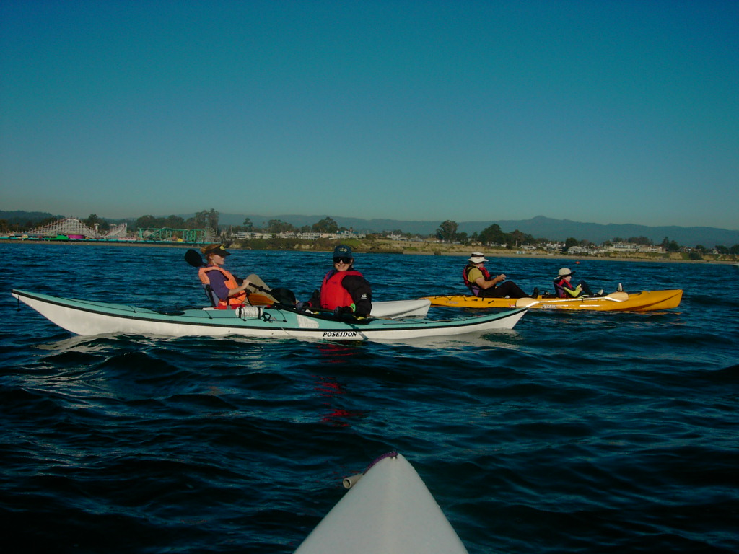

One Day Tours Page
_____Save the page as odt in the pages folder (you created this folder in the previous step).
_____ Include a Navigation Bar at the bottom of the page. You may use a table or pipes ( | ) to separate each link

Here is the content and layout for this page.

One Day Tours

Choose from a wide variety of one day tour packages starting as low as $375.

Sailing Package
Start the day with lessons on basic sailing techniques, then after a well prepared lunch take out on your own to explore the seas.
_______________________________________________

Kayaking Hawaii’s Famous Ocean Caves and Arches
The Hawaiian Islands are full of ocean caves and beautiful ocean arches. Start at Pillar Point and kayak to Whale Cave, Dead Man’s cave and the Rainbow Arch.
_______________________________________________

Cliff Climbing and Diving
On this tour you arrive at the bottom of High Rise rock via a 45 minute boat ride. After climbing to the top of the rock you take the quit way back by diving back to the boat.

Home | About EHT | Ultimate Packages

Ultimate Packages Page
_____Save the page as upp in the pages folder (you created this folder earlier).
_____ Include a Navigation Bar at the bottom of the page. You may use a table or pipes ( | ) to separate each link

Extreme Hawaiian Tours
Ultimate Packages

If you are looking for the ultimate in adventure and excitement then here are some choices we thing you might enjoy. A word of caution, these tours are not for the feint at heart.

Volcanoes – Up Close and Personal
After a half-day hike up to the volcanoes’ crest enjoy lunch with a view of all of the Hawaiian Islands as well as the inside of a boiling caldera. This tour comes complete with live lava flows, spouting vents with molten lava and lots of hot rocks. The hike down is through an old lava tube that extends one mile down the side of the mountain and ends at the sea.
_______________________________________________

Hangliding Off South Point
Hawaii is best seen from above and this three day package will provide you with views you will never forget. On the first day our professional instructors will teach you the basics of hangliding and you will make your first flight. On day two our instructors will fly with you as you view the islands from above. After your glide you will land on the beach for a complete dinner luau.
_______________________________________________

Hand Feeding the Sharks
If you like getting close to wildlife then this is your chance. Dive to the old fish trawler wreck and feed some of the largest sharks in Hawaii. Spend several days diving at various wrecks around the island and checking out the wildlife up close and personal.

Home | About EHT | One Day Tours

