Capuchino High School / ROP Name: ____________________
Computer Systems Design I Date: _____________
A+ Hardware Technician Tutorial Per. ___________
Computer Hardware

Answer the following questions as you read through the A+ Hardware Technician Tutorial at the LearnThat website. (www.learnthat.com)

Section 1:

1. Label the following types of computers from the pictures below.

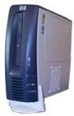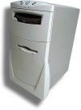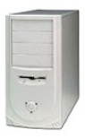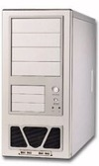

_______________ _______________ ________________ _________________

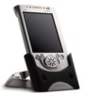
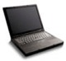
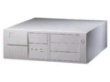
_______________ ________________ _______________

2. Identify the device below. What is it used to prevent?

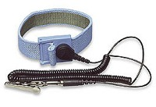

3. List the 6 basic parts of every PC:
- -

- -

- -

Section 2:
4. Label the following diagram:
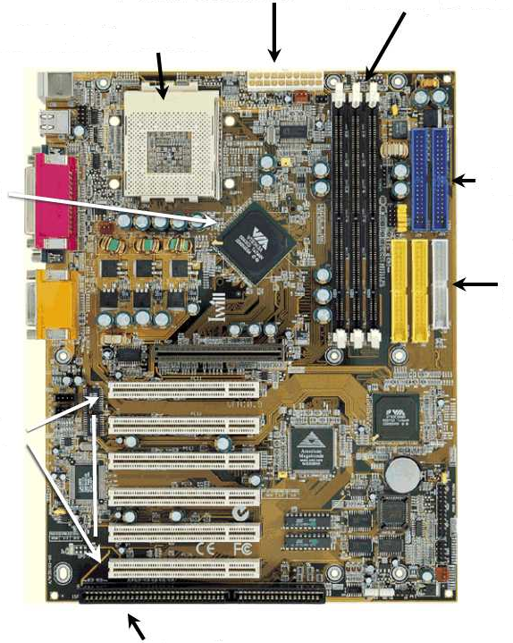

5. What is this? How is it’s performance measured?
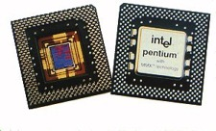

6. What does DMA allow components to do?

7. What are the bit transfer and speed of the following expansion slots?

Bit Transfer Speed

ISA

MCA (Microchannel)

EISA

VESA Local Bus

PCI

Section 3:
8. What are the three major drive interface standards?

9. What is ATAPI and which drive interface supports it’s use?

10. Each SCSI chain supports _____ or ______ devices and must be _____________________ on each end of the chain.

11. Before installing an operating system you must __________________ and _____________________ your hard drive.

12. What is the advantage of using CD-R’s for backup storage?

13. What are the 4 ways tape back drives can be connected to your computer?

14. What is the size of the typical floppy drive on most modern systems?

