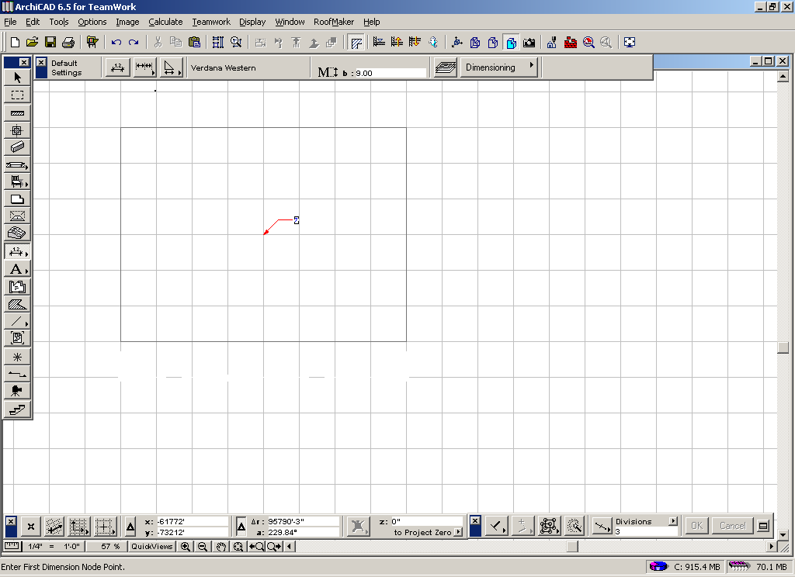

The ArchiCAD Window
Specific toolbars and panels will be referenced throughout this course so it is vital that you know the names of each box or window. Label each of the boxes or windows with the appropriate name. Keep this page handy for quick reference.

Explore the parts of the window to try and find the following tools. For each tool or option indicate where you found it. The first one has been completed for you.
- Save - go to File menu and then select Save
- Grids and Background
- ArchiCAD 6.5 Reference Guide
- Zoom In
- Drag a Copy
- Step by Step Tutorial
- Redraw

