**Framework of the project**

A ZIP file ([Forms.zip](http://xmltwo.ibo.org/publications/DP/Group3/d_3_itgsx_tsm_1001_2/html/xmltwo.ibo.org/publications/DP/Group3/d_3_itgsx_tsm_1001_2/IA/Forms.zip)/[Forms_OpenDocument.zip](http://xmltwo.ibo.org/publications/DP/Group3/d_3_itgsx_tsm_1001_2/html/xmltwo.ibo.org/publications/DP/Group3/d_3_itgsx_tsm_1001_2/IA/Forms_OpenDocument.zip)) is available that provides the basic structure of the project for students. This should be downloaded from the OCC and placed in an area of shared access. Students can copy the ZIP file into their workspace and extract the contents.

It is most strongly recommended that the contents of this ZIP file are used as the framework for the project.

The initial file format of the documentation files is RTF in order to ensure maximum compatibility with a range of different software types. However, particularly with the insertion of screenshots, the file size may increase to become unmanageable, so it is strongly recommended that the file type is saved as PDF, DOC or HTM/HTML. Guidance in modifying the links in the original cover page form is included later in this section.

The ZIP file unpacks as follows.

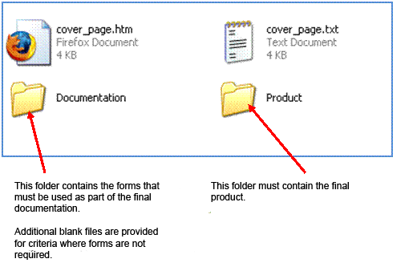

The documentation folder should contain the following files.

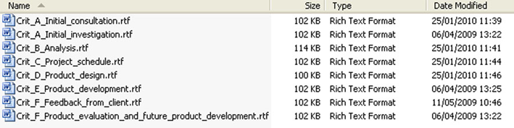

The links in the cover page (**cover_page.htm**) will not open the documentation files, as the links are based on these documents being saved as PDF files.

**Using the forms**

Students are required to use the following forms in the development of their project.

The forms are as follows.

|  |  |  |
| --- | --- | --- |
| **Item** | **Criterion** | **Format** |
| Cover page | G | TXT/HTM |
| Analysis | B | RTF |
| Project schedule | C | RTF |
| Product design | D | RTF |

Blank RTF files for extended writing are also included in the ZIP file and may be used.

The files are for the following criteria.

|  |  |
| --- | --- |
| **Item** | **Criterion** |
| Initial investigation | A |
| Consultation with client | A |
| Product development | E |
| Feedback from client | F |
| Product evaluation and future product development | F |

**Links on the cover page**

During the development of the project the student may have converted the RTF files in the forms into other formats such as PDF, DOC or HTM/HTML. This will mean that the original links on the cover page will no longer function as intended.

Reasons for the conversion of the file type may include the following.

* The insertion of images into the RTF file has caused the file size to become too large to manage and transfer easily.
* The student may wish to link all the documentation files as web pages so as to facilitate easy navigation and viewing.

Where file extensions have changed, the HTML on the cover page must be edited to enable the links to function. For example, if the student has saved the initial investigation as a DOC file, the original link on the cover page does not function.

It is strongly recommended that students use a simple text editor such as Notepad or TextEdit to edit the cover page. This will ensure that the links are maintained as relative rather than absolute, which may occur if more complex word processing software is used.